Into the Woods Auditions: Narrator/ Mysterious Man – “No More,” m. 69 – 109
- Please prepare measures 69-109.
- Vocal Audio Track Example: https://drive.google.com/file/d/1sQnatkkLWB17UVXTH2adAl21o5Kywzef/view?usp=sharing
- Rehearsal Tracks for Audition: https://drive.google.com/file/d/1qcT5R7oGbiLrT269uIAmNlUntUG3vBBj/view?usp=sharing
Start

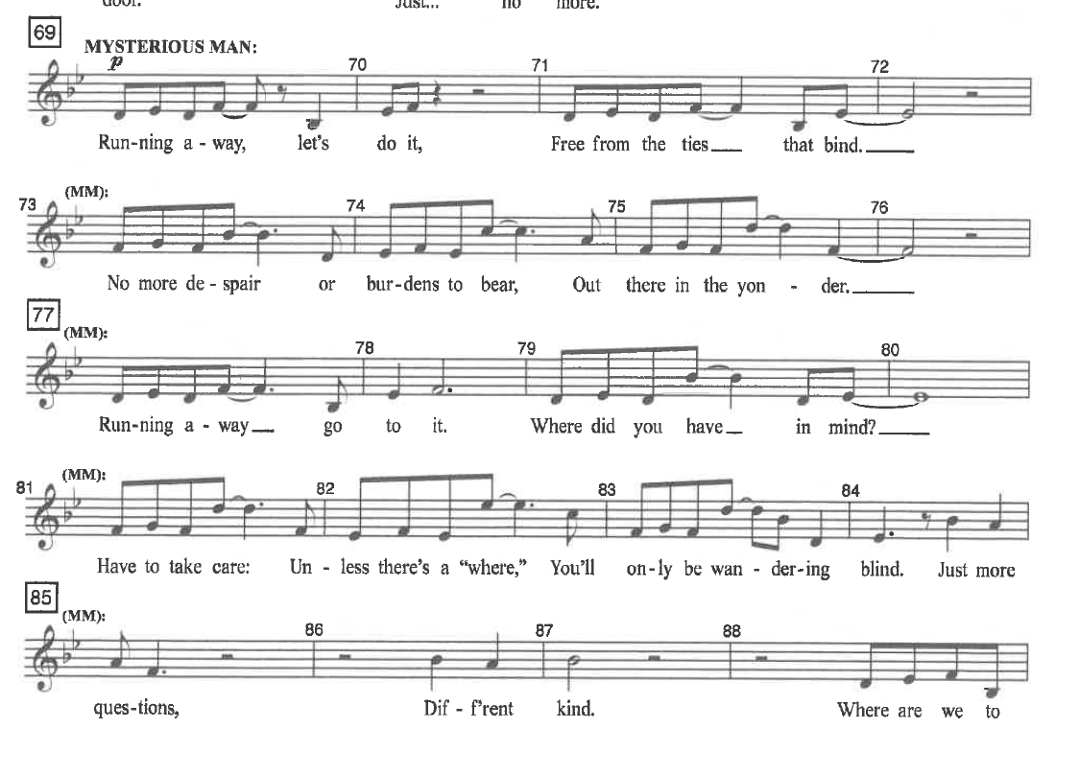
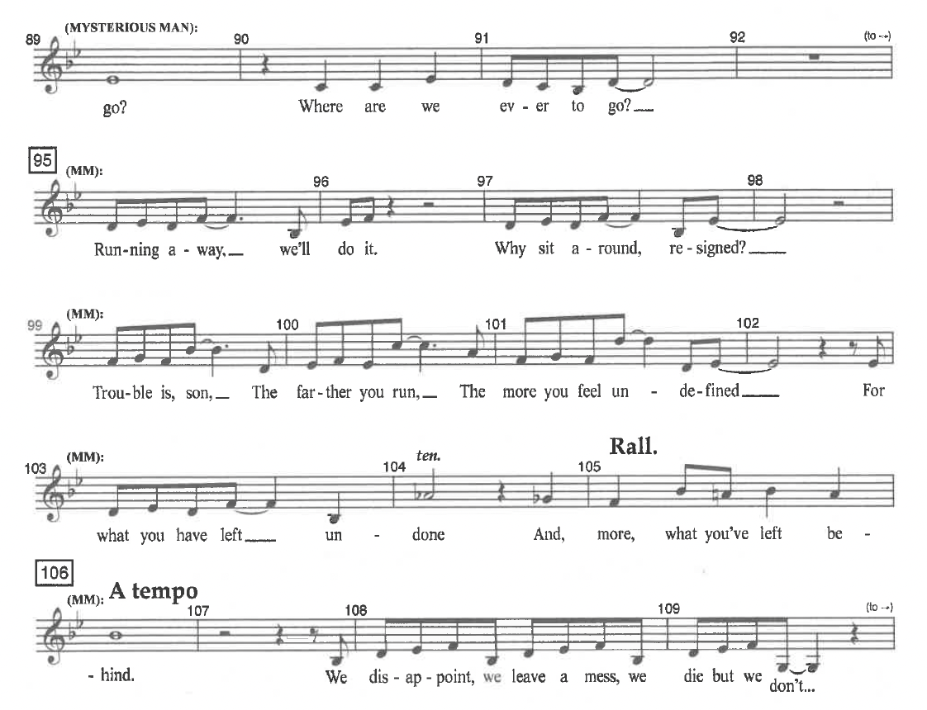
End

